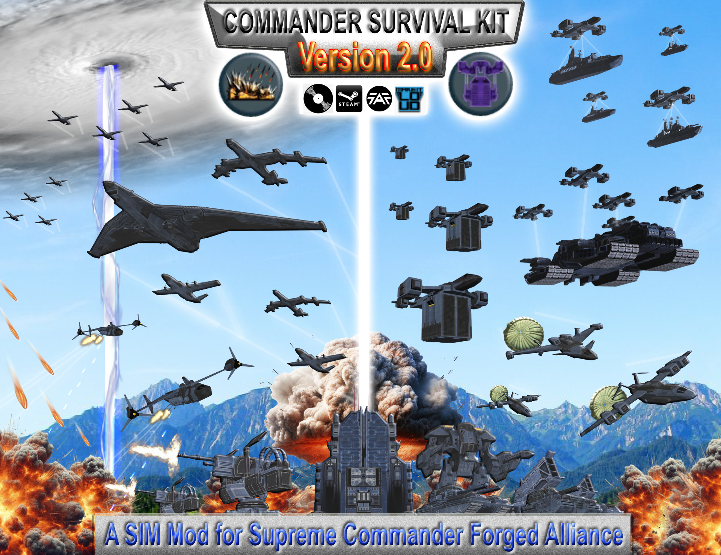
Hello Commander and welcome to the Install Instructions of the Version 2.0 Major Release of the Commander Survival Kit.
This Document gives you an Overview how you can install the Mod for each Version/Variant of the Game.

If you need any help please contact me here:
Moddb:
https://www.moddb.com/mods/commander-survival-kit-csk
FAF Forum:
https://forum.faforever.com/topic/6034/commander-survival-kit-a-new-sim-mod
Discord:
https://discord.gg/p8XGNc5KgA

Install Instructions (Manual)


Steam Version of the Game

If you want to Install the Mod for the Steam Version of the Game
You will need to do these following Steps:

Step | Description
1 | Open the downloaded Commander Survival Kit Version 2.0.7z File with Winrar or 7-Zip  You should see an gamedata and mods Folder inside it
2 | Copy and paste the mods Folder here:  C:/Users/yourusername/Documents/my games/Gas Powered Games/Supreme Commander Forged Alliance
3 | Accept the Dialog to overwrite it if there is already an Mods Folder.
4 | Copy and paste the gamedata folder here:  C:/Program Files (x86)/Steam/steamapps/common/Supreme Commander Forged Alliance
5 | Accept the Dialog to overwrite it
6 | Start the Game and activate the Mod in the Mod Manager  I recommend quitting the game once afterwards and restarting it again
7 | Start a Match and Enjoy the Mod


Retail Version of the Game

If you want to Install the Mod for the Retail Version of the Game
You will need to do these following Steps:

Step | Description
1 | Open the downloaded Commander Survival Kit Version 2.0.7z File with Winrar or 7-Zip  You should see an gamedata and mods Folder inside it
2 | Navigate to the Game Directory where you have installed it  The Game Directory is usually called Supreme Commander Forged Alliance.  If you open it you should see the bin, gamedata and several other Folders inside it
2 | Copy and paste the mods Folder into the Game Directory
3 | Accept the Dialog to overwrite it if there is already an Mods Folder.
4 | Copy and paste the gamedata Folder into the Game Directory
5 | Accept the Dialog to overwrite it
6 | Start the Game and activate the Mod in the Mod Manager  I recommend quitting the game once afterwards and restarting it again
7 | Start a Match and Enjoy the Mod


Loud Version of the Game

With the Release of the new Love-Loud Launcher by Balthazar you can Load Installed Mods from the Steam Documents Path now
However this requires to do the Install Instructions of the Mod for the Steam Version above first.

If you have done this you can press this following Button:


It should look so after you have press it:

After that is Done do Step 5 and 6 below

Alternative If you want to fully Install the Mod in the regular way for Loud
You will need to do these following Steps:

Step | Description
1 | Open the downloaded Commander Survival Kit Version 2.0.7z File with Winrar or 7-Zip  You should see an gamedata and mods Folder inside it
2 | Copy and paste the mods Folder here:  Steam:  C:/Program Files (x86)/Steam/steamapps/common/Supreme Commander Forged Alliance/LOUD/usermods  CD:  Path Depends where you have Install the Game/Supreme Commander Forged Alliance/LOUD/usermods
3 | What about the included gamedata Folder?  For Loud you don’t need to install the two .scd Files, which are included in the gamedata Folder of the downloaded Commander Survival Kit Version 2.0.7z File. The Reasons for this are simple First Loud doesn’t has access to the Campaign and Second Loud has an integrated support for Custom Lobby Options. So this makes this Step fully irrelevant in this Case and can be Skipped
4 | Start the Game with the Love-Loud Launcher and activate the Mod in the Mod Manager  I recommend quitting the game once afterwards and restarting it again
5 | Start a Match and Enjoy the Mod

FAF Version of the Game

The FAF Version of the Game registers whether the Steam or Retail Version of the game is installed.
Depends on which Version you have you can follow the Install Instructions of the Mod for Steam or Retail above to install the Mod.
Important:
However similar like Loud you don’t need to install the two .scd Files, which are included in the gamedata Folder of the downloaded Commander Survival Kit Version 2.0.7z File for FAF. The Reasons for this are simple First FAF has access to the FAF Coop Campaigns, which have their own Lobby and Second FAF has an integrated support for Custom Lobby Options.
Alternative you can simple Install the Mod from the FAF Modvault as following:
Step | Description
1 | Open the FAF Client and Login if needed
2 | Navigate to the Mods Tab
3 | Write „Commander Survival Kit“ into the „Name“ Textfield and press the Button „Search“
4 | The Search Result should display the Mod now which looks like that:  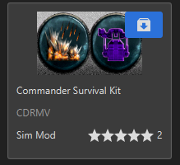
5 |   Press the Button to Install the Mod
6 | Navigate to the Play Tab > Custom Games > Create Game  If you press on the SIM Button the Mod should appear in the Mod List  Activate the Mod it should look like so at the End:  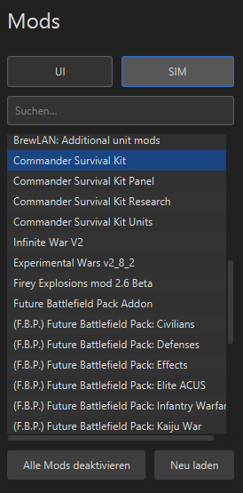
7 | Create a Match and Enjoy the Mod
Official Github Repository

The Commander Survival Kit is of course still not finished with this Major Release.The Mod will still get new Features and Functions in the Future. So if you want to play with the most recent Development Version of the Mod in Early Access you can always download it from the official Github Repository here:

https://github.com/CDRMV/Commander-Survival-Kit
Please follow the Install Instructions on Github to install the Mod correctly.
The Github Repository includes two other Mods of this Project, which are still in Development:
- Commander Survival Kit Units (short CSK Units)
- Commander Survival Kit Research (short CSK Research)

So you can get the Early Access to them as well if you want.
Important:
Keep in Mind that the Github Version of the Commander Survival Kit and the other two CSK Mods are Early Access Material.
That means it is not allowed to publish them anywhere without my permission. If you want to use a few of my Units or Functions in your own private Mod please ask me first to let me know to set the Conditions for it. Thank you so much for your understanding.

